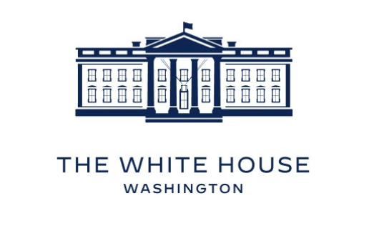

FOR IMMEDIATE RELEASE
[DATE]

[HEADLINE]

[WRITE THE BODY OF YOUR PRESS RELEASE IN THIS BOX]

